Jad Aboul Hosn
201403418
EECE 200
Homework 1
September 27, 2013

Problem 1 :
- The amplitude of x is 0.5 v
The amplitude of y is 3 V
The amplitude of z is 2 V

- For graph of x :

- Frequency : F = 1/1.25 = 0.8Hz
- Period : T= 1.25 s
- Angular Frequency : W = 2 π f = 2*π*0.8 = 5.02 rad/s

For graph of y :

- Frequency : F = 1/6.25 = 0.16 Hz
- Period : T= 6.25 s
- Angular Frequency : W = 2 π f = 2*π*0.16 = 1rad/s

For graph of z :

- Frequency : F =1/2.5 = 0.4 Hz
- Period : T= 2.5 s
- Angular Frequency : W = 2 π f = 2*π*0.4 = 2.51 rad/s

- The signal that has the highest frequency, is the one that has the lowest period: 1.25s <2.5s <6.25s
So the graph x has the highest frequency: 0. 8 Hz
- y(t)= A sin ( w t + Ѳ )

For the first graph of x :
- The graph x is ¼ a period off set of time:

2 $π$ rad 1 period
π/2 rad ¼ period

Ѳ1 = π/2 rad = 90$°$

- The graph y is not off of time:

Ѳ2 = 0 : there is no phase shift

- The graph of z:
2 π rad 1 period
π/5 1/10 period

- Validation :

- For the graph x =

We have that at t=0 :
y = V = 0.5 V

- Replacing in the equation: y(0) = A sin(w(0) + Ѳ ₁)
- We have that A: the amplitude of the graph x, is the maximum value : A = 0.5 V
- The angular frequency for the graph of x : w = 5.02 rad/s

Replacing in the original equation:

y(0)=0.5sin(Ѳ ₁)
0.5=0.5 sin (Ѳ ₁)
Sin (Ѳ ₁) = 1
Ѳ ₁ = 90°= $\frac{π}{2}$ rad

X: Y (t) = 0.5 sin (2.76 t + $\frac{π}{2}$)
- For the graph of y:

- We have that at t=0 :
y = V = 0V
- Replacing in the equation: y(0) = A sin(w(0) + Ѳ ₂)
- We have that A: the amplitude of the graph y, is the maximum value : A = 3 V
- The angular frequency for the graph of y : w = 1.00 rad/s

Replacing in the original equation:

y(0)=3 sin(Ѳ ₂)
0=3 sin(Ѳ ₂)
Sin(Ѳ ₂) = 0
Ѳ ₂ = 0° = $0$ rad

Y : Y(t) = 3 sin (1t) = 3 sin (t)

- For the graph of z:

- We have that at t=0 :
y = V = 1.5V
- Replacing in the equation: y(0) = A sin(w(0) + Ѳ ₃)
- We have that A: the amplitude of the graph y, is the maximum value : A = 2 V
- The angular frequency for the graph of y : w = 2.51 rad/s

Replacing in the original equation:

y(0)=2 sin(Ѳ ₃)
1.5=2 sin(Ѳ ₃)
Sin(Ѳ ₃) = 3/4
Ѳ ₃ = 48.59°= $0.84$ rad

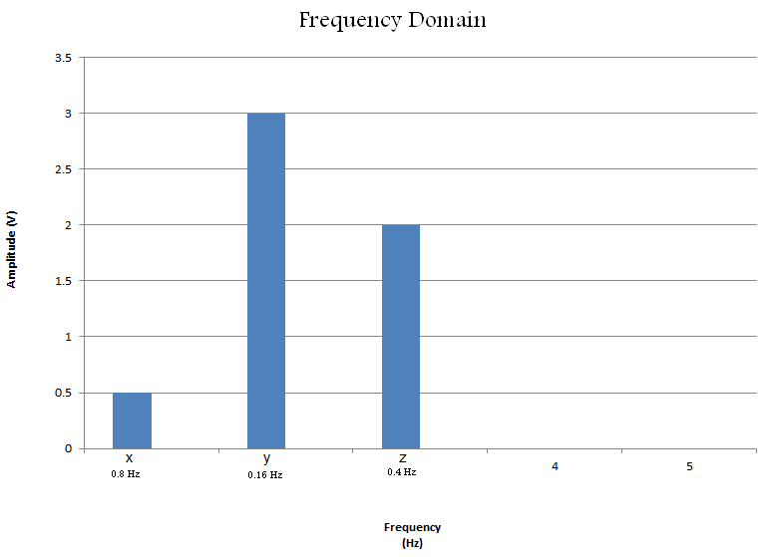
Problem 2:
- Virgin Radio Station. Frequency 89.5 FM. We can say that it fits within range , because it change with in 200 kHz of its value.
- The bandwidth of AM station is 10 kHz.
In fact, the number of AM stations that could fit inside this whole range (530 kHz 1700 kHz) is: 1700-530 = 1170 / 10 = 117 stations.
One station that uses AM is Sawt el Ghad.

- Yes there is an operating system using DVB in Lebanon: OSN.
- In fact, such technology doesn’t require anything other than a TV tuner that can be connected directly to TVs. At this rate, the TV sets can stay the same.

Problem 3:

- The dimensions of this image are 4*4 = 16 pixels.
- One pixel requires 2 bits : 2^1 = 2 bits. In fact, We need two bits , because we have here 4 different shades of gray : 2 ^ 4 = 16 pixels.
We define each level of gray :
- Black 00
- Dark Gray 01
- Light Gray 10
- White 11
$$\left[\begin{aligned}00 10 01 10 \\ 01 11 01 01 \\ 11 10 11 10 \\ 00 11 10 01\end{aligned}\right]$$
- $\left[\begin{aligned}0 2 1 2 \\ 1 3 1 1 \\ 3 2 3 2 \\ 0 3 2 1\end{aligned}\right]$

- The movie is at a rate of 40 frames/s. Time : 3 min = 3*60 = 180 s
40 frames/s * 180 = 7200 frames/s
Each frame is 16 pixels : 7200 * 16 = 115200 pixels
Each pixel is represented by 2 bits : 115200*2 = 230400 bits
At a rate of 8 bits / 1 byte : 230400/8 = 28800 bytes = 0.02746 mega bytes

Problem 4:
- 11001.010 ₂

1*2^4 + 1*2^3 + 0 + 0 + 1*2^0 + 1*2^-2 = 25.25 ₁₀

- 364.125 ₁₀
 |  | rem
364/2 | 182 | 0
182/2 | 91 | 0
91/2 | 45 | 1
45/2 | 22 | 1
22/2 | 11 | 0
11/2 | 5 | 1
5/2 | 2 | 1
2/2 | 1 | 0
½ | 0 | 1
101101100

0.125*2 | 0.25
0.25*2 | 0.5
0.5*2 | 1
 | 001

101101100.001 ₂
- 261 ₈
= 2*8^2 + 6*8^1 + 1*8^0 = 173 ₁₀

173 ₁₀

173/2 | 86 | 1
86/2 | 43 | 0
43/2 | 21 | 1
21/2 | 10 | 1
10/2 | 5 | 0
5/2 | 2 | 1
2/2 | 1 | 0
½ | 0 | 1
10101101

- 1001011 ₂
We take each 4 alone :

0100 1011
- 0100 = 0*2^3 + 1*2^2 + 0 +0 = 4
- 1011 = 1*2^3 + 0 + 1*2^1 + 1*2^0 = A

4A ₁₆
- 2AB ₁₆
= 2*16^2 + 11*16^1 + 12*16^0 = 700 ₁₀

